- When Contact is selected under navigation, it should redirect to a page like below.

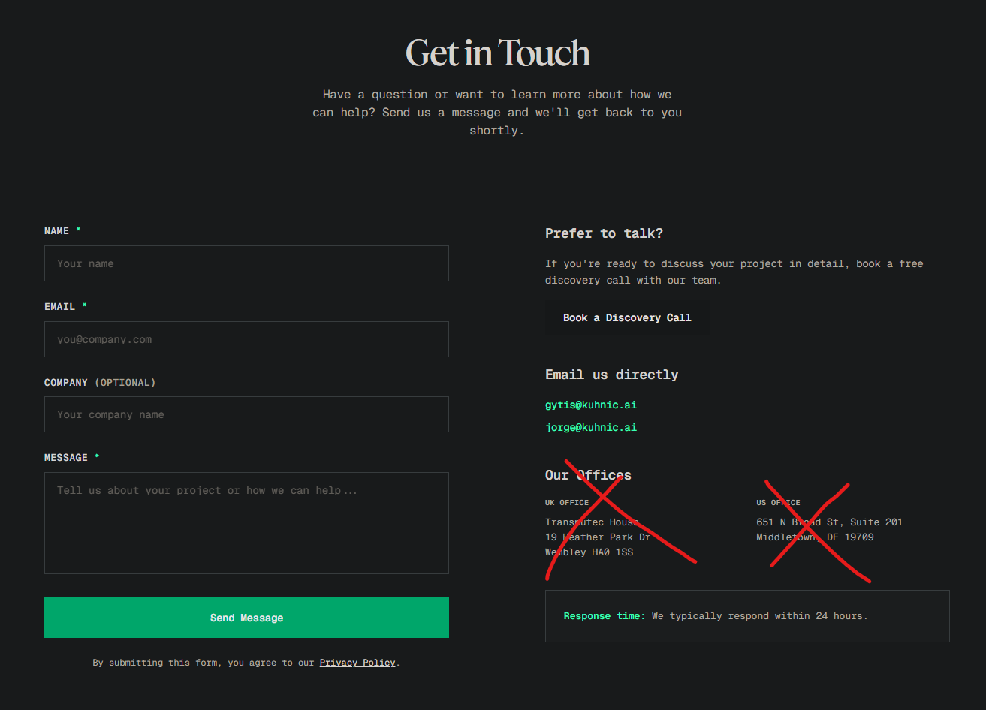
- The information highlighted orange should appear on the left side. The form should appear on the right side (as is)
  - “Get in Touch” - Add and use similar message as above.
  - Prefer to talk?
    - “If you’re ready to discuss your project in detail, book a free consultation with our team.”
  - Email us directly
    - michael@impackta.online
  - Our offices (delete)
  - Response time (include)
  - Form details
  - Use the same as above:
    - Name
    - Email
    - Company (Optional)
    - “Type of Business” change this to “Industry”
    - Message
  - Privacy notice below “Send Message” should read the same as above i.e. “By submitting this form, you agree to our Privacy Policy” (hyperlink “Privacy Policy”)

- I noticed you removed “Book a Free Call” that appeared under the chatbot icon. However, I mentioned in chat that I had changed my mind and to leave it. Can you please add this back and it should redirect directly to Calendly.

- The Instagram handle directs to @expansionaic instead of @impackta.ai

- When “Book Consultation / Book Free AI Consultation” is selected anywhere on site it should redirect to Calendly. Please look at a great example on this site: https://www.kuhnic.ai/. I want mine to do the same and contain the same/similar details as below apart from where it says “Book a Discovery Call” that should read as “Book a Free AI Consultation”

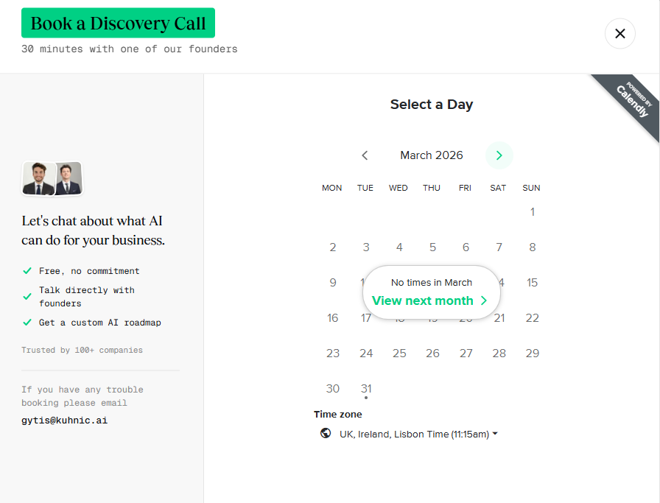

- “Sport & Performance” should be added as an industry on homepage and on drop down form.

- FAQs
- I would like FAQs added somewhere on site similar to: https://www.kuhnic.ai/ . You can keep the same/similar questions but maybe just reword the contents under each but keep subject matter the same.
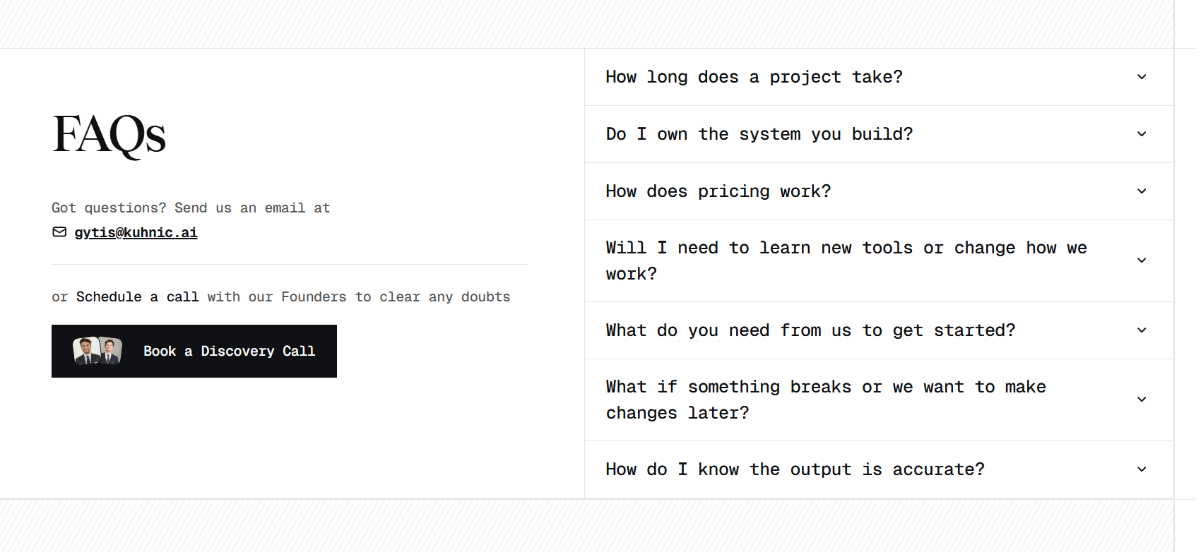

- I notice that the three tiered “Services” do not direct to a page that contains details for each service. I think it’s very important this is as clear as possible. Can you do something similar to: https://www.kuhnic.ai. If you select “Services”, you’ll see how they’ve presented theirs for AI Systems and Automations. We may need something concise for “Custom AI”. Would we still need Solutions if the same info is incorporated within Services? I’ll trust your judgement here. If you could reflect this on my site using the data you already have and that on example, that site would be excellent!

  - For each Service, I want something at the bottom of page similar to below. But instead of “Book a Discovery Call” “Book a Free AI Consultation” that directs to Calendly.
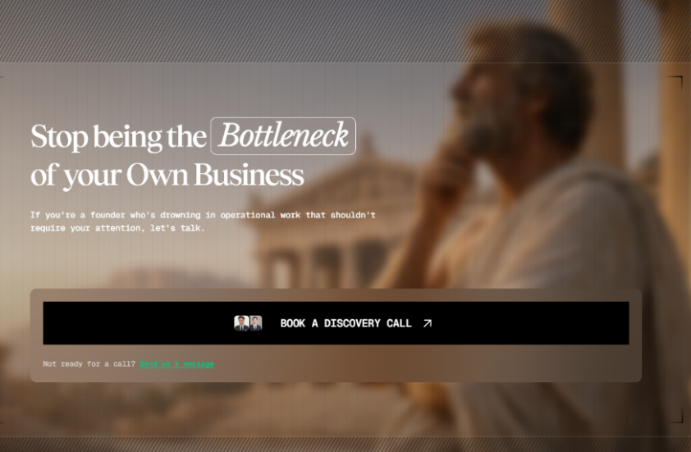

- I notice we don’t have any testimonials – please add 3-4 random/generic examples as believe not having any will affect credibility and gaining clients. As I scale, I’ll reach out to add more.

- You can delete below as I’ll include this in the email I send them once they schedule on Calendly

